Mutagenesis protocol (Jennifer Doudna lab)

- The protocol is able to make site-directed mutagenesis for single or multiple nucleotides, introducing new sequences, and deleting a chunk of sequences.

- Design the primers following the rules below.

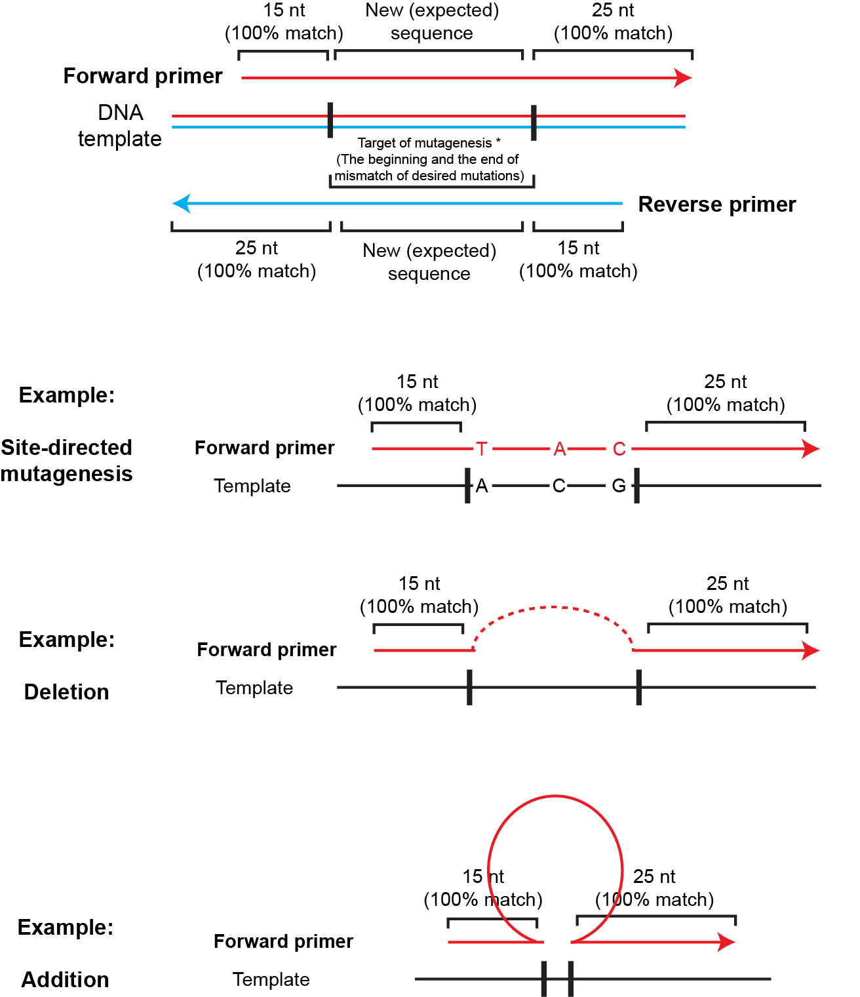

- Synthesize primers using standard desalting method (no extra purification needed)

- Perform long-range PCR with PfuTurbo (Agilent # 600250), PfuUltra (Agilent # 600380) or PfuUltra II (Agilent # 600670).

- Condition for PfuTurbo:

